# Name:________________________________ Strand:________________________________

Grade level: ___________________________

# Worksheet #5

**ACTIVITY: I WRITE IT!**

**DIRECTIONS**: Your task is to write the basic concepts and principles of Structural – Functionalism, Marxism, and Symbolic Interactionism by writing your answer in the Venn Diagram. Based on your answer from the article that you have read earlier.

STRUCTURAL FUNCTIONALISM



SYMBOLIC INTERACTIONISM

MARXISM

**ACTIVITY: REFLECTIVE WRITING**

DIRECTIONS: Your task is to write a reflection paper on of the three (3) major social sciences theories: Structural – Functionalism (How important is structural functionalism in understanding the different institutions in society?), Marxism (How our society influence or affect an individual’s principle?) and Symbolic Interactionism (Does symbolic interactionism affect our daily life? Why?). Use your notebook to write your answers.

**REFLECTIVE WRITING RUBRIC**

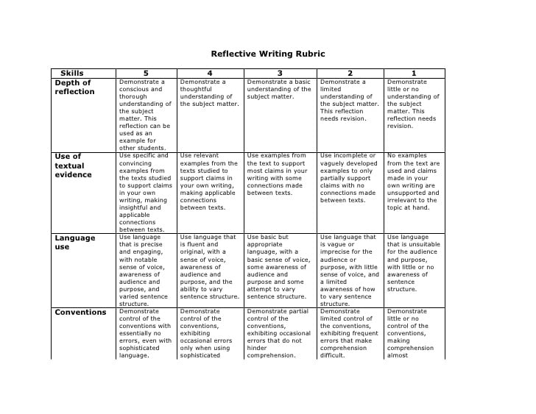

**Post Test**

**DIRECTIONS.** Choose the best answer to the following questions/statements below.

**1. According to Functionalism, each of the social institutions contributes important functions for society. Which of the following institution can offer a way to transmit a society’s skills, knowledge, and culture to its youth?**

A. Education B. Religion C. Family D. **E**conomics

**2. Which of the following does NOT describe structural-functionalism?**

A. a perspective in sociology that sees society as a complex system whose parts work together to promote solidarity and stability.

B. tells that society is made up of groups or institutions, which are cohesive, share common norms, and have a definitive cultur**e**.

C. explains that the way society is organized is the most natural and efficient way for it to be organized.

D. None of the above.

**3. It is the amount of socially necessary labor-time needed to produce an article under the normal conditions of production and with the average degree of skill and intensity of the time.**

A. Use value C. E**x**change value

B. The labor theory of value D. Surplus value

**4. For groups to be cohesive in a social context, positive membership attitudes and behaviors have to be produced and maintained. It can be looked at on both an individual and group level at a group level is directly affected by the individual members. Which of the following concepts describes the bonds that bring people together in a society?**

A. Social **S**tability C. Social Inequality

B. Social Cohesive D. Social Cohesion

**5. Robert Merton believes that 5 situations are facing an actor in Structural Functionalism. Which of the following is statement is/are true?**

A. Conformity occurs when an individual has the means and desire to achieve the cultural goals socialized into them.

B. Innovation occurs when an individual strives to attain the accepted cultural goals but chooses to do so in a novel or unaccepted method.

C. Ritualism occurs when an individual continues to do things as prescribed by society but forfeits the achievement of the goals.

D. **A**ll of the above

**6. According to Symbolic Interactionists, human beings differ from animals__________.**

A. Because humans show greater affection than animals

B. **B**ecause human being can take the role of the other

C. Because humans are only proactive and not reactive like animals

D. All of the above

**7. Because on Mead’s discussion of generalized other, which of the following statements is TRUE?**

A. Societal expectations **h**ave little impact on who we think we are.

B. There is no “me” at birth, it is formed through continual symbolic interaction

C. The “I” is more important than the “me” informing our sense of self

D. The generalized other is really who we are, we just don’t understand what Mead is saying

**8. Which one of the following is a reason why Marx cannot be rejected because of his ideological orientation?**

A. **M**arxism is the only **s**ociological theory that is ideologically biased.

B. Marx tried to hide his ideological orientations.

C. Marx argued that a violent overthrow of capitalism is the only way to end exploitation

D. Marx was essentially a humanist, not a bloodthirsty revolutionary

**9. What would be Marx’s argument that needs to happen to transform a society's culture?**

A. the mass media would need to be changed

B. **M**arx was essentially a humanist, not a bloodthirsty revolutionary

C. the economic foundation would have to be changed

D. new technologies would need to be introduced

**10. Which of the following is true about symbolic interactionism?**

A. It is a type of lens for looking at the world

B. It is focused on language and symbols in day to day life

C. It includes the belief that reality is socially constructed

D. **A**ll of the answers are correct